
Our SEN Information Report for Parents
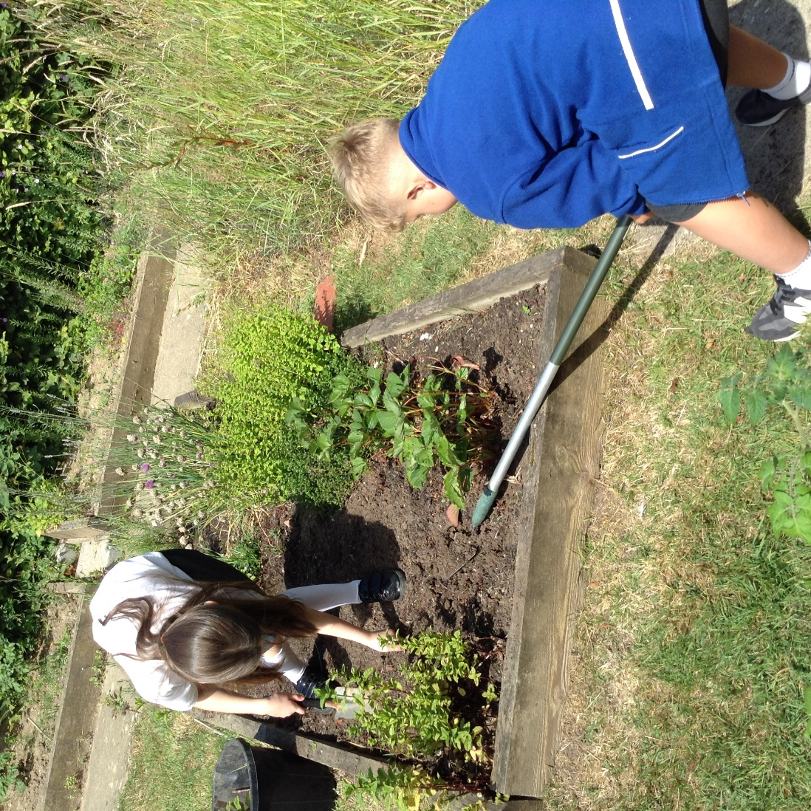
"Every child deserves the best start in life and the support that enables them to fulfil their potential.”

Early Years Statutory Framework, 2021

Introduction
Slinfold CE Primary School is an inclusive school. We believe that all children are entitled to an education that is appropriate to their needs, encourages high standards and promotes the fulfilment of potential.
We define special educational needs using the Special Educational Needs and Disability (SEND) Code of Practice (2014) which states that:
“A person has SEND if they have a learning difficulty or disability which calls for special educational provision to be made for him or her. At compulsory school age this means he or she has a significantly greater difficulty in learning than the majority of others of the same age, or has a disability which prevents or hinders him or her from making use of facilities of a kind generally provided for others of the same age in mainstream schools.”
SEND Code of Practice (2014)
The school’s most recent OFSTED report (January 2020) identified that;
“Pupils with special educational needs and/or disabilities (SEND) have their needs met, pupils are supported well in class. As a result, SEND pupils are able to access all areas of the curriculum and achieve well.”

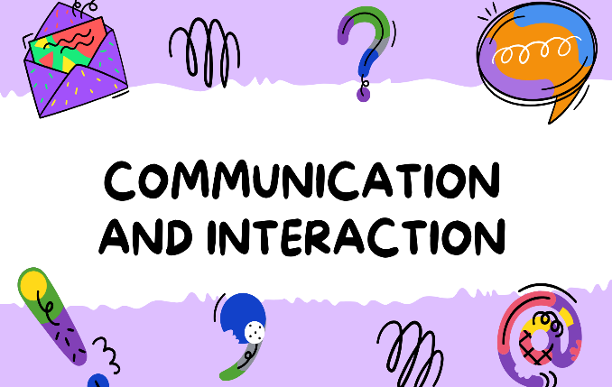
4 Areas of SEND

Communication and Interaction Cognition and Learning
E.g. - Autistic Spectrum Condition, expressive E.g. Dyslexia

and receptive language difficulties
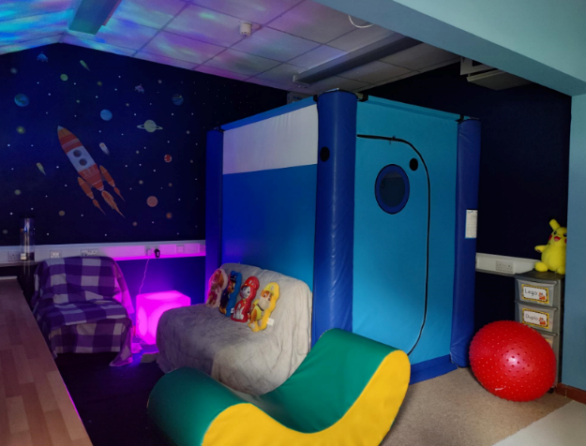

Sensory and/or Physical Needs Social, Emotional and Mental Health Difficulties
E.g. visual or hearing impairment E.g. ADHD , anxiety
Policies and Procedures
At Slinfold CE Primary we have had a clear approach to identifying and responding to SEND. Class Teachers, supported by the Senior Leadership Team, make regular assessments of children’s progress. When monitoring children’s progress, Class Teachers look for children who have made less than expected progress given their age and individual circumstances. They look to see if progress:
- is significantly slower than that of their peers from the same baseline
- fails to match or better the child’s previous rate of progress
- fails to close the attainment gap between the child and their peers

At Slinfold CE Primary we have a designated teacher, known as the Inclusion Leader, who is responsible for overseeing SEND in the school. Our current Inclusion leader is Mrs Collins. Parents can contact the Inclusion leader through the school office or phone 01403 790253.
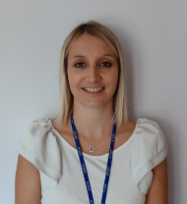

Our Graduated Approach to SEND Support
If the school has concerns about the progress of a child, we will take action to remove any barriers to learning using the OAIP (Ordinarily Availably Inclusive Practice) and put effective special educational provision in place. The school has adopted a graduated approach to this support. Wave 1 provision includes strategies that are available to all children. Wave 2 provisio includes small group interventions whilst Wave 3 provision provides individual targeted support.
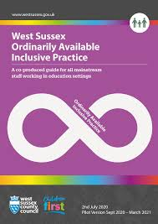
Wave 1 Provision
If a Class Teacher has concerns about the progress of a child, the school’s first response is to ensure that the child receives high quality teaching, targeted at the area of weakness. The Class Teacher will use the OAIP to support with strategies. The Class Teacher will complete a Wave 1 Monitoring form. This form identifies the child’s current level of attainment, together with the views of the child and parent. The form will also outline which Wave 1 strategies are being put in place. After an agreed length of time, the child’s progress will be reviewed. If the child has made progress, Wave 1 support may end or be adapted. If the child is not making progress with this additional support, Wave 2 provision will be put in place.

Wave 2 Provision
Wave 2 provision is when a child accesses small group intervention that is in addition to whole class teaching. The child has also have an Individual Learning Plan (ILP) drawn up in partnership with the child and parent. The ILP will contain approximately three targets for the child to work towards. These will be reviewed on a termly basis.

Wave 3 Provision
Wave 3 provision is individual targeted support. The Inclusion Leader will put Wave 3 provision in place if a child has failed to make progress through Wave 2 support.
In addition to on-going formative assessments, the school may also use a range of specialised tests to assist in the identification of children’s learning difficulties. Tests that the school may use include:
- SPAR Spelling Test – a tool for testing literacy difficulties in children.
- Phonological Assessment Battery (PhAB) – used to assess different aspects of a child’s phonological processing.
- Salfords Reading Tests - measures reading accuracy and reading comprehension skills.
- Sandwell Early Numeracy Test - Assesses pupils' ability with numbers and identifies specific numeracy skills requiring targeted teaching.
- RAVEN – non verbal reasoning - assesses abstract reasoning and general cognitive ability.

If your child continues to require additional support, the school can request that the Local Authority carries out a statutory assessment (Education, Health and Care Needs Assessment) of your child needs. Being accepted for an assessment is not a guarantee that your child will be given an EHCP. After the school have sent in the assessment request, the statutory assessment team will decide whether they think your child needs fit the criteria for assessment. If an EHCP is issued after the assessment, this will outline the level and type of support your child will receive. Parents will have an annual review meeting to discuss the child’s progress and the EHCP will be updated.

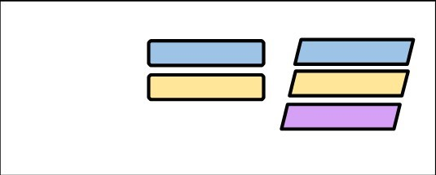
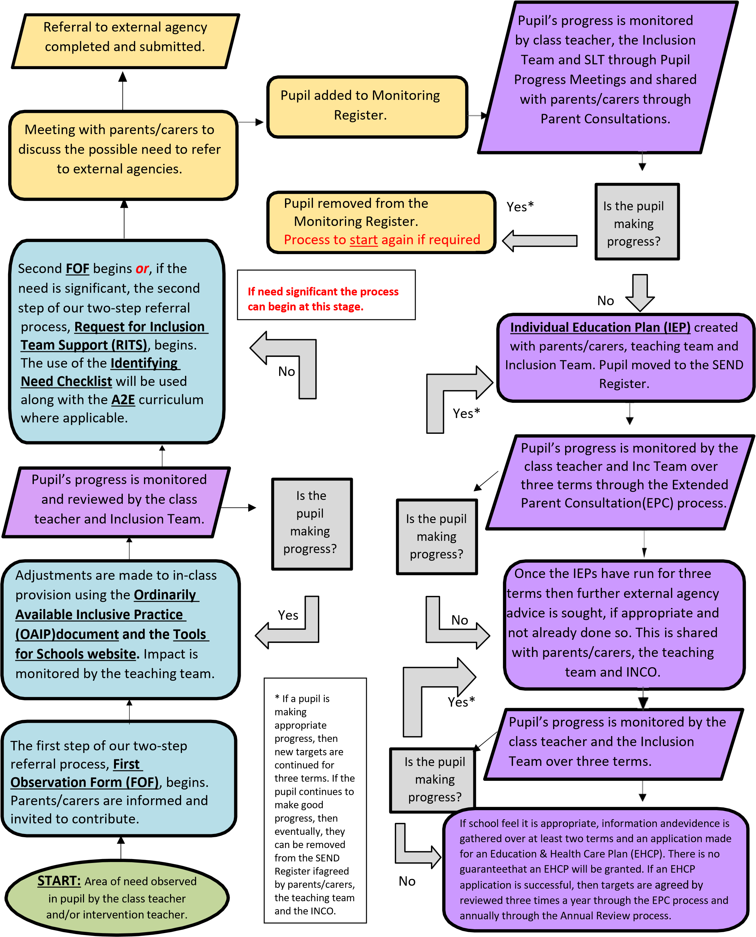

Teacher & Inclusion Lead
Teacher
INCO
Key
Slinfold CE Primary School and Pre-School SEND Flow Chart

Assessing and Reviewing Children’s Progress
Regardless of whether a child has accessed Wave 1, Wave 2 or Wave 3 provision, the support will take the form of a four-part cycle of Assess, Plan, Do and Review. This four-part cycle ensures that a child’s progress is constantly monitored and staff have checked that the intervention in place is both relevant and effective.
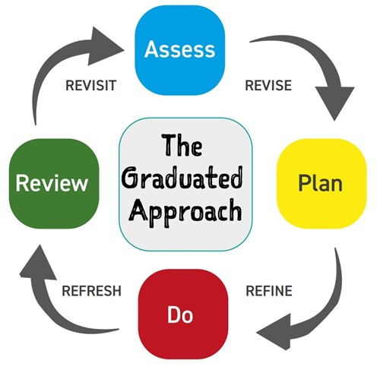
Assess – The Inclusion Leader and Class Teacher will carry out a clear analysis of the child’s needs. This analysis will draw on Class Teacher’s assessments, previous progress and attainment of the child, as well as the views of the child and parent.
Plan – The Inclusion Leader and Class Teacher will agree, in consultation with the parent and child, the adjustments, interventions and support put in place, along with a clear date for review.
Do – The Class Teacher or Teaching Assistant will deliver any interventions agreed to further support the child. If on Wave 2 or 3, evidence of the impact of these will be recorded in the child’s Learning Journal.
Review – The effectiveness of the support and interventions and their impact on the child’s progress will be reviewed and evaluated in line with the agreed date. The child and parent’s views will be incorporated into the review. The Inclusion leader and Class Teacher will revise the support in light of the child’s progress and development, deciding on any changes that need to be made to the provision.

Use of Outside Agencies
In some circumstances, the school may draw on specialist services such as the Speech and Language Therapy Service, Occupational Therapy Service, Physiotherapy Team, Learning Behaviour Advisory Team (LBAT) and Autism Social Communication team (ASCT). These services may carry out additional assessments to help monitor progress and support children further.




Our approach to teaching children with SEN needs
At Slinfold CE Primary School, our approach to teaching children with Special Educational Needs and Disabilities (SEND) is rooted in our inclusive and nurturing ethos. We believe that every child is a unique individual who deserves the opportunity to thrive, succeed, and feel valued as part of our school community. Our teaching is carefully adapted to meet the diverse needs of all learners, ensuring that lessons are accessible, engaging, and appropriately challenging. Staff work closely with pupils, parents, and external professionals to provide personalised support and interventions that promote both academic progress and emotional well-being. We foster a caring environment where children feel safe to take risks, build confidence, and celebrate their achievements. Inclusion is at the heart of our practice—children with SEND learn alongside their peers, developing positive relationships, mutual respect, and a strong sense of belonging within our school community.


Staff Training and Development
Slinfold CE Primary is a member of The Weald Alliance SEND Hub. The Inclusion Leader meets with other SENCos / Inclusion Leads in the locality each half term. Through these meetings the Inclusion Leader accesses the skills and advice of other SENCos as well as training opportunities from outside agencies. Through membership to The Weald Alliance SEND Hub, the Inclusion Leader, Class Teachers and TAs also have access to training from various outside agencies. In addition to the support of the Weald Alliance SEND Hub, the school also benefits from close links with outside agencies.
The Inclusion lead is fully trained with the National SEND Award qualification. All staff at schools have had training at different times to meet the needs of all the children they are working with.
This may include training in –
- Autism
- Dyslexia
- ELSA (Emotional Literacy Support)
- Speech and Language
- For medical needs such as epilepsy or diabetes, staff are trained as necessary to administer medication / procedures.
In addition to these, many staff are skilled in individual areas to deliver specific intervention programmes.

How is the School Accessible for Children with Special Educational Needs?
Slinfold CE Primary is committed to ensuring that every aspect of the school day, including extra-curricular clubs, are accessible to all children.

The school has easy access to all areas and a ramp at the entrance of our KS2 classrooms, ensuring that we are complaint with DDA requirements. We ensure that, wherever possible, equipment used is accessible to all children, however TA’s will support children with additional needs in situations they might otherwise be unable to access.
We have an accessible toilet and changing facilities. For children needing adaptive aids in the classroom, we work with occupational / physiotherapists to ensure all needs are met. We have a sensory space for children who need time out of the classroom and additional resources such as ear defenders, standing desks, TheraBand’s and other specialist equipment is available as and when needed.
After school activities and our wrap around care is accessible to all children, including those with SEND. We make reasonable adjustments to ensure all children are supported to access the same activities and experiences.

How do we capture the views of the child?
Every pupil in our school has an individual Pupil Profile that outlines their strengths, interests and aspirations alongside any areas they find challenging, what helps them to learn and some targets they would like to work towards. These pupil profiles are created collaboratively with parents and form part of our transition process in the summer term
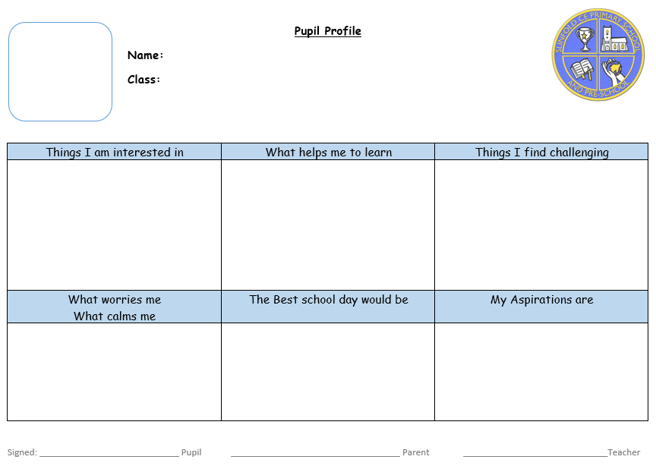
For pupils with SEN, these profiles are stuck in their Learning Journal, which documents their SEN provision and children regularly look at and amend these throughout the year. This ensures that all staff working with the child have a clear understanding of how best to support the child’s learning, well-being, and participation in school life. The profiles are reviewed regularly to ensure they remain accurate and responsive to each pupil’s evolving needs.
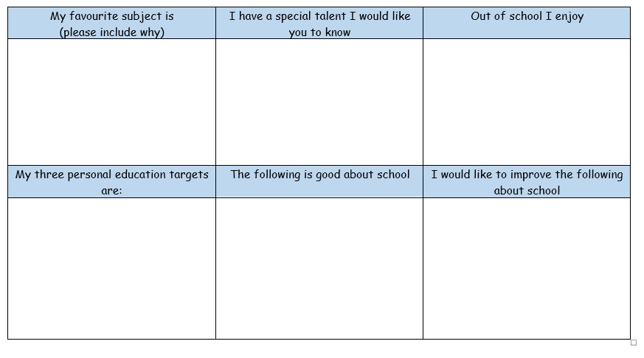

Working with Parents and Carers


At Slinfold CE Primary School we have an open-door policy where parents/carers are encouraged to discuss any concerns they may have with the Class Teacher. If appropriate, a meeting with the Inclusion Leader has been arranged.

Parents/carers are kept informed about their children’s progress at Parent Consultation Evenings and additional ILP review consultations, which are offered termly with the Class Teacher. However, parents/carers have been encouraged to discuss their child’s progress throughout the year. Parents/carers are involved in reviewing targets and their views have been recorded on the ILP.

Arrangements for Supporting Children with Transitions Between Phases in Education
Starting Primary School –

For children entering reception, the following transition arrangements will be put in place -
- Parents will meet with the Class Teacher and TA in person during coffee morning / stay and play sessions.
- The Class Teacher will liaise with the child’s pre-school/nursery setting prior to them starting.
- For some children with SEND, the Inclusion Leader and Learning Support Assistants (LSAs) will meet with parents, children and pre-school/nursery staff. Social stories were sent home for parents to share with their child.
- For children with SEND, photographs will be provided of key members of staff and areas around the school.
- The Inclusion lead will also liaise with the relevant outside agencies to discuss the transition needs of children with SEND.
- We will also ensure that any relevant paperwork is transferred to us from nursery settings.

Moving on to Secondary School -
For children moving on to secondary school, the following arrangements will be put in place:
- The Year 6 class teacher will hold in person meetings with secondary school staff
- The Inclusion Lead will share relevant information with secondary school staff and ensure all relevant records are transferred.
- The secondary schools provide transition units of work for the pupils.
- The Inclusion leader will liaise with relevant outside agencies
- A transition page with information and activities will be added to the school website.
- The Head of Year 7 will visit for a Q and A session.
- An in-person transition day will be held for all pupils.
- Any children who may require additional visits to the secondary school will be facilitated by the Inclusion Leader’s and Learning Mentor, with follow up sessions back at Slinfold.

Moving from Class to Class -
For children transferring to new classes within Slinfold CE Primary, the following arrangements will be put in place:
- For children with SEND, Social stories are sent home.
- For children with SEND, photographs will be provided of key members of staff and areas around the school.
- For children with SEND, additional time with TAs/LSAs will be organised and a transition programme completed. For some pupils, this programme will include the completion of a transition booklet.
- Teachers meet in person to discuss and plan for individual pupil’s needs.
- All pupils take part in a morning session in their new class for September, before the end of the summer term.

Supporting Your Child’s Social and Emotional Development and Wellbeing
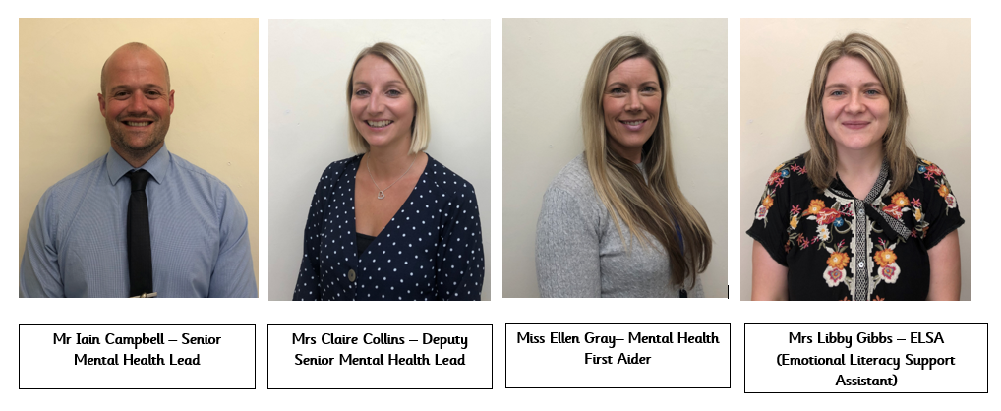
At Slinfold, we have a Senior Mental Health Team-


Children with social and emotional needs or anxiety will initially be supported in school, possibly in a small nurture groups or 1:1 support if needed. This is carried out by Mrs Gibbs, our School Emotional Literacy Support Assistant (ELSA). If a concern continues, or the level of the support is higher, we may refer them to the Mental health Team (Thoughtfull)for further support. Thoughtfull provide one to one evidence-based interventions in schools for mild to moderate mental health issues such as anxiety and depression. They also give advice to school staff and liaise with external specialist services, to help children and young people to get the right support and stay in education.

How Do I Make a Complaint?



The school aims to work in partnership with parents to ensure a collaborative approach to meeting children’s needs. All complaints are heard through the school’s complaints policy and procedure.

What Support is There Beyond School?

Services available for identifying and assessing children and young people with special educational needs from birth to age 25 can be found on the West Sussex Local Offer website. Areas covered are education, health, social care, support services and leisure.
The provision, support and resources available at Slinfold CE Primary School can be found in the school’s Local Offer. This can also be found on the school’s website.
West Sussex SENDIAS provide impartial information, advice and support to children and young people who have SEND (special educational needs and/ or disabilities) for those aged 0-25 and their parent carers.

The main areas we can help you with:
- Schools, college or training
- Getting the right healthcare
- Getting the right support at home, school or in the workplace
More information can be found here - https://westsussexsendias.org/about-us/

Contact Information

Special Educational Needs and Disabilities Coordinator – Claire Collins

Headteacher – Iain Campbell

Please contact us via the school office on 01403 790253 or office@slinfold.w-sussex.sch.uk

