|  |
| --- |
| **Geographical Skills and Fieldwork** |
| * Find the four **countries** of the **United Kingdom** using map skills * Compare the **human** and **physical geographical features**   of the four **countries** saying how they are similar and  different.   * Use Google Earth to start at school and zoom out. What do you notice? * Observe **aerial view** photographs and know what they show * Use the **compass points** to describe the **countries** of the   **United Kingdom** in relation to each other. |

|  |  |
| --- | --- |
| **Vocabulary** | |
| aerial view | a view from above |
| capital city | the city where the government sits. **London** is the  **capital city** of **England** and the **UK**. |
| city | a large town. London is a city. |
| compass  point | any of the [main](https://www.collinsdictionary.com/dictionary/english/main) points of a compass: north, south, east  and west |
| country | an area of land that is controlled by its own government. |
| England | a country in the **United Kingdom**. Haywards Heath is a  **town** in **England**. |
| flag | a piece of cloth (often) which can be attached to a pole and which is used as symbol of a particular **country** |
| human geography | features of land that have been impacted by human activity |
| island | a piece of land that is completely **surrounded** by water |
| Great  Britain | An **island** that is made up of **England**, Scotland and  Wales. |
| London | **London** is the **capital city** of **England** and the **UK**. |
| physical  geography | natural features of land |
| sea | a large area of salty water that is part of an ocean |
| surrounded | to be present all around |
| United  Kingdom | The **UK**, is officially known as the United Kingdom of  Great Britain and Northern Ireland. It includes **England**, Scotland, Wales and Northern Ireland. |
| village | a small group of houses, perhaps with a few shops, that  are often in the countryside .Lindfield and Cuckfield are **villages.** |

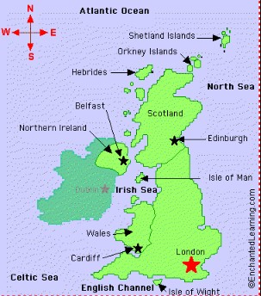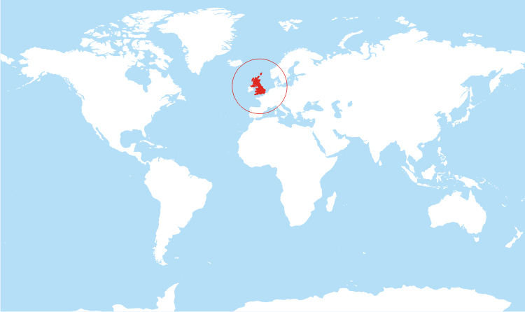

UK

Great

Cornard

**Diagrams**

* The **UK**, is officially known as the United Kingdom of

Great Britain and Northern Ireland

* The **UK** includes the island of **Great Britain,** Northern Ireland and many smaller islands
* **Great Britain** is an **island**—it is **surrounded** by **seas**:
  + Irish Sea
  + North Sea
  + English Channel
* The Republic of Ireland is not a **country** of the **United Kingdom.**
* Haywards Heath is a **town** in **England**.
* **England** is a **country.**
* There are four **countries** in the **United Kingdom (UK):**
  + **England**
  + Scotland
  + Wales
  + Northern Ireland
* Each of these **countries** has a **capital city, flag** and

national flower:

**What will I know by the end of the unit?**

|  |
| --- |
| **What should I already know?** |
| * The **country** I live in is called **England**. * I live in Haywards Heath, which is a **town** in   **England.** |

|  |  |  |  |
| --- | --- | --- | --- |
| **Country** | **Capital City** | **Flag** | **National Flower** |
| England | London |  | rose |
| Scotland | Edinburgh |  | thistle |
| Wales | Cardiff |  | daffodil |
| Northern Ireland | Belfast |  | shamrock |