

**Identification and provision for learners with specific learning difficulties in literacy (including Dyslexia)**

At Slinfold Primary School we believe that every child deserves the best and work hard to foster their talents and strengths. We will provide the tools and support to enable every child to achieve their full potential, to be inspired by others and to believe in themselves.

At Slinfold Primary School Mrs Collins is the Inclusion lead and is the named link person for dyslexia.

The British Dyslexia Association say that dyslexia is a neurological difference and can have a significant impact during education, in the workplace and in everyday life. As each person is unique, so is everyone's experience of dyslexia. It can range from mild to severe, and it can co-occur with other learning differences. It usually runs in families and is a life-long condition.

It is important to remember that there are positives to thinking differently. Many dyslexic people show strengths in areas such as reasoning and in visual and creative fields.

We have agreed to use the **Rose definition of dyslexia**:

*‘Dyslexia is a learning difficulty that primarily affects the skills involved in accurate and fluent word reading and spelling.’*

• Characteristic features of dyslexia are difficulties in phonological awareness, verbal memory and verbal processing speed.

• Dyslexia occurs across the range of intellectual abilities.

• It is best thought of as a continuum, not a distinct category, and there are no clear

cut-off points.

• Co-occurring difficulties may be seen in aspects of language, motor co-ordination, mental calculation, concentration and personal organisation, but these are not, by themselves, markers of dyslexia.

• A good indication of the severity and persistence of dyslexic difficulties can be gained by examining how the individual responds or has responded to well-founded intervention.

In addition we believe that:

1. Children with learning difficulties that do not have their origin in dyslexia may present as having difficulty with mastering literacy skills but this may be for reasons other than dyslexia.
2. If a child does not make expected progress after a short intensive block of intervention, this may show they are at risk of dyslexia.
3. Dyslexia is a learning difference that requires a graduated process of identification and support.
4. Current research indicates dyslexia is a phonological processing difficulty overall, however 20% of cases do not show phonological processing difficulties. Of these 20% it may be that a significant number have co-existing special needs that impact on responsiveness to intensive support provided for dyslexia e.g.: visual processing difficulties, motor sensory integration difficulties.
5. Support for dyslexia should be ongoing, consistent and offer over-learning opportunities.
6. Dyslexia is a life-long specific learning difficulty that is not related to intelligence, race or social background.
7. It is crucial to hear the voice of the child and to support their self-esteem.

**Graduated Approach**

At Slinfold we use a graduated approach in order to support children’s learning. The following 5 level model is used for identifying and supporting literacy and dyslexic difficulties and will assist teachers in making decisions about a child. At all levels, the voices of the children and their parents/carers will be clearly heard.

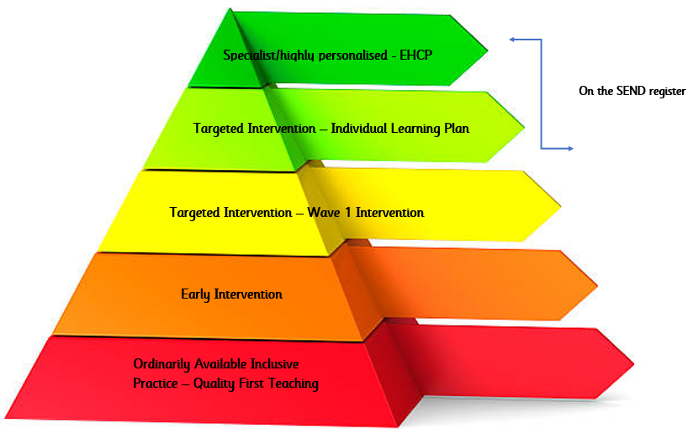

**1.Ordinarily Available inclusive Practice - Quality First Teaching**

At this stage it is the class teachers who identify literacy difficulties. They will notice individual differences and adjust their teaching and use quality first teaching strategies. They will also be aware of the possibility that some children may have dyslexia. However, it is not their role to diagnose that a child has dyslexia. If parents or carers raise the question of dyslexia at this stage, class teachers will explain that this possibility will be explored with the Inclusion Leader in the light of the response to literacy interventions. They will also explain what whole class strategies are being put in place and that, at this stage, no different intervention would result even if a positive identification of dyslexia was made.

**Teaching Strategies**

• Multi-sensory teaching strategies

• Use of inclusive teaching techniques, e.g. talking partners, peer support

• Effective adaptation of work e.g. by task/by outcome/by material

• Pre teaching vocabulary

• Limited copying off the board

• Strengths as well as difficulties of all pupils are known

• Visual support e.g. visual timetable

• Variety of learning styles addressed within a lesson

• Various methods of recording encouraged e.g.: mind mapping, ICT, drama, pictures, flowchart, and oral presentations

• Chunking instructions into small parts

• Teaching memory strategies e.g. mnemonics, visualisation

• Providing brain breaks

• Positive marking to support personal targets

• Using a high quality phonics programme, ‘Song of Sounds, allowing pupils to learn at their own pace, and with opportunities for over learning and reinforcement.

• Access to pastoral support for self-esteem, confidence and anxiety management

**Equipment, resources and the environment**

• Tabletop ‘toolkits’ may include high frequency word lists, topic words, sound mats, writing frames, post it notes, highlighter pens, personal dictionaries, visual prompts for active listening, b/d cards, pencil grips, reading rulers/tinted overlays, sloping boards

• Access to ICT to support reading and writing, e.g. Clicker 7, , voice recorders, sound buttons, laptops & IPads.

• Coloured backgrounds and dyslexia friendly fonts e.g. Infant Sassoon

• Displays to include (as appropriate), alphabet, high frequency words, topic words, days of the week, months of the year, narrative prompts (who, where, when, what happened, end), phonic prompts, mind maps, all with picture support.

• Access to high interest/low reading age books.

**2. Early Intervention**

At this stage, the Class Teacher will involve the Inclusion Leader to undertake a screening tool (WESFORD) to identify specific areas of literacy difficulties. This is not a diagnostic tool. This will highlight areas of strength and weaknesses and will indicate which areas a child requires further support. Intervention will then be put in place to support these areas.

It should be stressed that this is not a formal identification of dyslexia, rather at this stage, the main decision being made is about what more should be done to counter the particular difficulties the child is experiencing.

**3. Targeted Intervention**

The class teacher will involve the Inclusion Leader to assess the child’s strengths and difficulties and response to the current intervention. The child will be moved onto the SEN register and an Individual Learning Plan will be written specifically for their needs. These targets will be reviewed on a termly basis with both the parents and the child’s views taken into consideration. Specific literacy intervention may be put in place such as the use of Nessy.

**5. Specialist Intervention**

The school may feel that they need further advice from external professionals such as the West Sussex Learning Behaviour Advisory Team. Parents may decide to pay a dyslexia qualified professional to do a dyslexia assessment for the child. A formal EHCNA request may be made.

**Access Arrangements and Dyslexia Identified**

Dyslexic difficulties do not automatically entitle pupils to access arrangements to be made for National assessments/examinations. There are different types of access arrangements that are possible for pupils i.e. reader, scribe, rest breaks, additional time, use of ICT and as such there are different requirements for each of these.

**Code of Practice**

Dyslexia is listed in the Code of Practice under Cognition and Learning.

**Useful Websites**

[**http://www.thedyslexia-spldtrust.org.uk/**](http://www.thedyslexia-spldtrust.org.uk/)

[**https://www.nessy.com/uk/**](https://www.nessy.com/uk/)

[**https://www.bdadyslexia.org.uk/**](https://www.bdadyslexia.org.uk/)