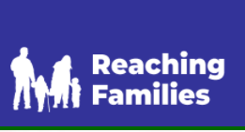  Telephone – 01903 366360 | REACHING FAMILIES  Support for families of children and young people with SEN and disabilities in West Sussex
  Citizens Advice Horsham  Lower Tanbridge Way  Horsham  RH12 1PJ  Monday – Friday 10am – 4pm  0808 2787969 | CITIZENS ADVICE IN WEST SUSSEX  Citizens Advice is able to provide support and advice on a number of issues. They can offer advice over the phone, by webcam or via email.
 | HORSHAM FOODBANK  Horsham Foodbank can provide 3 – 5 days’ worth of emergency food for those in crisis
 | HORSHAM MATTERS  Horsham Matters is a Christian charity that aims to demonstrate love of our neighbour by relieving hardship through the provision of essential services (food, fuel and shelter) in order to make a positive, long-lasting impact on people's lives.
 | NSPCC  Support and tips to help you keep children safe. From advice on children’s mental health to staying safe online, support for parents and what to do if you’re worried about a child.
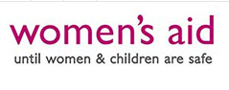  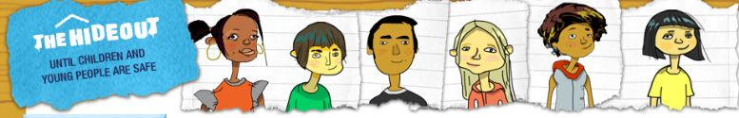  Live Chat Available –  https://www.womensaid.org.uk/ | WOMEN'S AID  IF YOU ARE A CHILD OR YOUNGER PERSON AND HAVE BEEN AFFECTED BY DOMESTIC ABUSE, WE’RE HERE TO HELP.  Women's Aid have created this space to help children and young people to understand domestic abuse, and how to take positive action if it's happening to you.
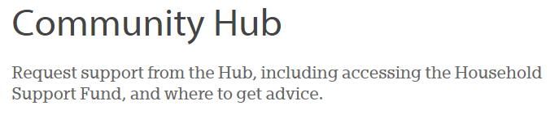 | WEST SUSSEX COMMUNITY HUB  Local support including financial support through the government's Household Support Fund (Option 4)
 | SHELTER HOUSING ADVICE  Emergency Hotline - Opening times: Monday to Friday, 8am - 8pm | Weekends and bank holidays, 9am - 5pm.  0808 800 4444
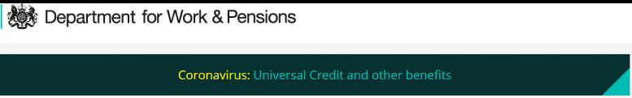  https://www.gov.uk/browse/benefits | DEPARTMENT FOR WORK & PENSIONS  Employment and Benefit Support
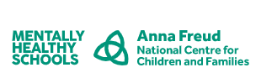  https://mentallyhealthyschools.org.uk/about/ | MENTALLY HEALTHY SCHOOLS  Mentally Healthy Schools is a free website for UK primary and secondary schools and further education settings, offering school staff and parents information, advice and practical resources to better understand and promote children’s mental health and wellbeing.
  https://www.youngminds.org.uk/about-us/ | YOUNG MINDS  The UK’s leading charity for children and young people's mental health. Support and information on all aspects of mental health and wellbeing.
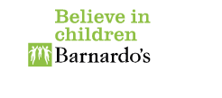  https://www.barnardos.org.uk/ | BARNARDO'S  We don’t abandon children because of who they are or what they’ve done. We listen to them, fight for their rights and do whatever it takes to protect and support them – because we believe that all children have the right to a happy and healthy life. Read more about our values.  At a time when more young people need specialist help with complex issues like sexual abuse, mental health problems and serious violence, our work is more vital than ever.  Times have changed and we've changed with them, but our belief in the potential of every child remains.
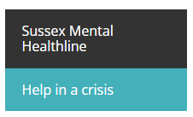 | sUSSEX MENTAL HEALTHLINE  If you are feeling suicidal or in crisis, the best thing to do is talk. Speak to someone you can trust or a service which can offer you support. If you think that someone you know is suicidal – ask them.  0300 5000 101  Monday – Friday 9am-5pm  Weekends 24 hours
  https://www.mind.org.uk/about-us/ | MIND  Advice for taking care of your mental health and wellbeing.
 | cHILDNET  Helping to make the internet a great and safe place for children and young people.
 | WEST SUSSEX YOUNG CARERS FAMILY SERVICE  West Sussex Young Carers Family Service supports young carers under 18 with information, support, advice and signposting.

