Topic: Romans |  |  |  |  | Strand: Movement
What should I already know? |  | What will I find out by the end of the unit? |  |  | Vocabulary
The Stone Age was when early humans used tools from stone. This lasted until the Bronze Age. The Bronze Age began when settlers arrived from Europe to Britain. These settlers brought with them ways of making tools from metal (bronze).  The Iron Age lasted from 800 BC till the Roman invasion (AD 43) - this was when people used tools made from iron. |  | Rise of the Roman Empire  Emperor Claudius – the first Roman emperor to successfully invade Britain  Julius Caesar – a famous Roman leader who attempted to invade Britain  Boudicca Queen of a Celtic tribe – known as the Iceni Tribe  Who were the Romans?  Roman soldiers  Roman Villas  Roman invasion of Britain  Romanisation of Britain (culture and beliefs)  Roman Empire by AD43 and the power of its army. Successful invasion by Claudius and conquest, including Hadrian’s Wall - Built to stop the Picts invading  Decline of the Roman Empire  Rome had Emperors and an Empire  Romans still influence and have an impact on what we do today.  In AD 43, the Romans under the order of Emperor Claudius, first invaded  Britain and Roman rule lasted until AD 410. |  |  | Romans: People from Rome in Italy  Celt: Collection of tribes with similar beliefs and traditions  Archaeologist: someone who studies the past by exploring old remains  Artefact: an object from the past that shows evidence of what life was like  Century: a period of 100 years  Christianity: the region based on the teachings of Jesus Christ  Invasion: to try and take over a place by force  Conquer: to overcome and take control of a place or people by military force  Migration: movement from one place to another in order to settle there  Chronological: A record of events in order  Empire: an extensive group of states run by a single monarch or state  Emperor: a sovereign ruler of an Empire  Influence: to have an effect on something or someone  Boudicca: Celtic Queen of the Icenti tribe  Soldier: a person who serves in an army  Hadrian’s Wall: a defensive fort in the Roman controlled area of Britain  Picts: an ancient person living in Scotland in Roman times  Decline: when something becomes smaller or decreases
Historical Skills and Enquiry
Examine Roman artefacts and use these to make inferences about the past.
Describe how Roman artefacts and ruins tell us about their culture, military, and religious beliefs.
Describe how the Roman society has had an impact on modern society.
Discuss the notion of an empire and an Emperor – compare with how Britain is run now through democracy.
Examine the timeline of the Roman period and consider where there was rapid change or very little – explain why. Compare what was happening in Rome and Britain at the same time.
Place key events onto a timeline in chronology.
Timeline | 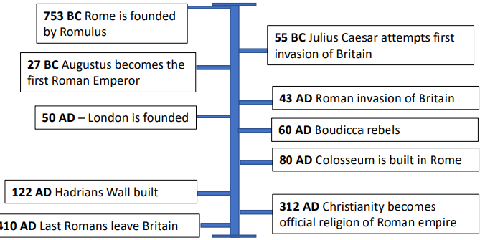 |  | Role of women | What was the role of women within society?  Did Boudicca have an impact on how women were viewed? |  | Food | How are their food different from ours? Did they inspire or bring any of their dishes over that we still use today? | Transport | How did the Romans change the way we transport and move around the country?

