Slinfold Primary School and Pre-School data
EYFS GLD | 72%
Phonics screening check | 83%
Pupils meeting the expected standard in reading, writing and maths | 33%
Average score in reading | 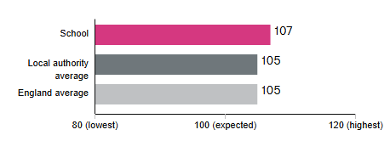
Average Score in maths | 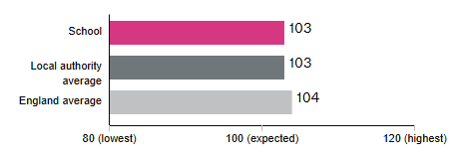
Grammar punctuation and spelling  Expected standard  Higher standard | 