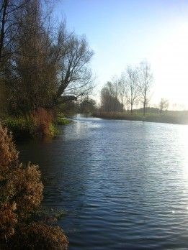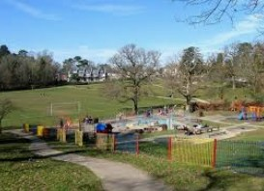

|  |  |  |
| --- | --- | --- |
| **Features of London** | | |
|  | **Human geographical**  **features** | **Physical geographical**  **features** |
|  | Many **houses**, **shops, offices,** apartments  and roads | River Thames    Parks and green spaces, hills too.  Image result for vegetation in london |
|  | Image result for london |
|  | Many **skyscrapers** |
|  | Image result for london skyline |
| London | Five **airports**  Over 200 **train stations** |
|  | Famous buildings such as Big Ben, the London Eye, the Houses of  Parliament, Bucking- ham Palace, Tower Bridge. This means that there are lots of **tourists.** |
|  | Some **ports** |

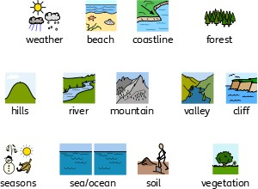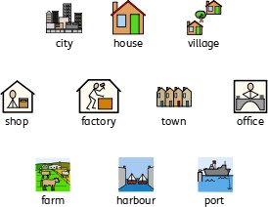

**Physical Geographical Features**

**Human Geographical Features**

|  |
| --- |
| **What should I already know?** |
| * The **town** I live in is called Haywards Heath. * Haywards Heath is in **England**, which is a **country**. * **Human** (houses, shops, parks, roads) and **physical features**   (river, woodlands) of Haywards Heath. |

|  |  |
| --- | --- |
| **Vocabulary** | |
| airport | a place where aeroplanes land and take off |
| capital city | the **city** where the government sits. London is the  **capital city** of England and the UK. |
| city | a large **town**. London is a **city**. |
| forest | a large area where trees grow close together |
| harbour | a sheltered **port** so that boats can be left there  safely. |
| hill | a naturally raised area of land, which is not as high as a mountain. |
| human features | features of land that have been impacted by human activity |
| physical features | natural features of land |
| port | a **harbour** area where ships [load](https://www.collinsdictionary.com/dictionary/english/load_1) and unload goods or [passengers](https://www.collinsdictionary.com/dictionary/english/passenger) |
| river | a large, natural stream of fresh water that flows into the sea or a lake. |
| skyscrapers | a very tall building with many floors |
| tourist | a person who is visiting a place for pleasure and  interest, especially when they are on holiday. |
| town | a large group of houses, shops and buildings where  people live and work. |
| train station | a place on a railway line where trains stop for people to get on and off trains. |
| vegetation | plants, trees and flowers |
| village | a small group of houses, perhaps with a few shops. Lindfield is a **village**. |

|  |
| --- |
| **Geographical Skills and Fieldwork** |
| * Use aerial photographs to compare Slinfold   and London. What is the same? What is different?   * Use a **map** to find London and Slinfold. * Contact pupils in schools in London. What questions do you want to ask them? What can you tell them about   Slinfold? |