British Values in Geography

Caring for each other,
Learning from each other,
Achieving with each other...
Guided by God.

Slinfold is a small, inclusive school with strong links to St Peter's Church at the heart of our rural village community. We strive to develop confident, resilient, and compassionate learners by providing an inspiring curriculum. Our supportive and respectful culture, based on our Christian values, enables all to flourish. Through consistently high expectations, challenge and a love of learning we aspire for excellence.
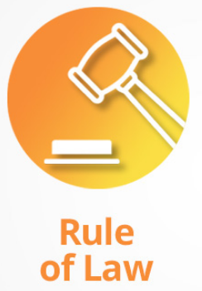 | 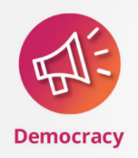 |  | 
Mutual Respect
Tolerance of those of different faiths and beliefs
In geography we explore different material’s, such as atlas’, maps and globes, which link and support knowledge. Children are taught how to correctly read and use them. Children work on identifying the different countries and their boundaries.  Through our geography curriculum we create a safe space for children to have a voice which enables them to express their own opinions surrounding the world around us. Children are encouraged to speak respectfully and be listened to as well. | In geography, we have respect for our fellow pupils and encourage everyone to have the confidence to express their ideas and opinions regarding geographical issues such as pollutions, environmental issues, water and globalisation. | In geography, when comparing and contrasting locations children will also explore the people living in these environments and their own individual liberties.  Children will have the freedom of making their own choices and decisions about the world. The children also know that there are boundaries that must be respected. | Mutual respect is taught and given when children are expressing their opinions and beliefs about different geographical parts of the world and societies within them.  Children are taught and encouraged to show respect to each other’s beliefs, feelings and opinions by giving each child a forum to share these on with the expectation that these must be listened to.  In geography, children will consider questions regarding how different cultures live and work throughout the world.  Children have the opportunity to explore how areas have changed and how the diverse needs in society has changed them.

