Topic: Countries and cities of the world |  |  |  | Strand: Geographical Skills and Fieldwork
What should I already know? |  |  |  | Vocabulary
- The town I live in is called Haywards Heath (West Sussex, England)  - West Sussex is in England, which is a country  - England, which is in the United Kingdom, is in the continent of Europe  - The seven continents (including Europe) and the five oceans  - The similarities and differences between Haywards Heath and Nairobi, the capital city of Kenya. Kenya is in the continent of Africa  - The main climate zones across the world and the biomes that can be found there. |  |  |  | Atlas Book of maps  Biome A natural area of the living world which has its own climate, vegetation and animals  Capital city The city where the government sit. London is the capital city of England and the UK  City A large town. London is a city  Climate The general weather conditions that are typical of a place  Climate zone Sections of the earth that are divided according to the climate There are three main climate zones: polar, temperate and tropical  Coasts An area of land that is next to the sea  Compass points Any of the main points of a compass: north, south, east, west, north-east, north-west, south-east, south-west  Continent A very large area of land that consists of many countries. Europe is a continent  Country An area of land that is controlled by its own government  Desert A large area of land, usually in a hot region, where there is almost no water, rain, trees or plants  Equator An imaginary line around the middle of the Earth at an equal distance from the North Pole and the South Pole  Globe A ball-shaped object with a map of the world on it  Human geography Features of land that have been impacted by human activity  Landmark A building or feature which is easily recognised  Language The communication of a particular country or people  Ocean One of the five very large areas of salt water on the Earth’s surface  Physical geography Natural features of the world  Population All the people who live in a country or area  Sea A large area of salty water that is part of an ocean  Tectonic Relating to the structure of the Earth’s surface or crust  Temperate A place which is never extremely hot or extremely cold  Tourist A person who is visiting a place for pleasure and interest, especially when they are on holiday  Trade The activity of buying, selling, or exchanging goods or services  Tropical Parts of the world that lie between the imaginary lines: Tropic of Cancer and the Tropic of Capricorn. The tropics have a humid climate, where the weather is hot and damp  Tundra A flat layer of land where the top layer is frozen. There is hardly any vegetation  Vegetation Plants, trees and flowers
Geographical skills and fieldwork
- Find the countries using a map, an atlas and a globe. What are the skills you need to use each of these?
- Compare the human and physical geographical features of the countries saying how they are similar and different. How can you present this information in different ways (eg Carroll and Venn diagrams)
- Research the different climate zones in each country
- Research the average temperature for each of the countries and create a chart to show this
- Observe aerial view photographs to compare countries and climate zones
- Use the compass points to describe the countries in relation to each other

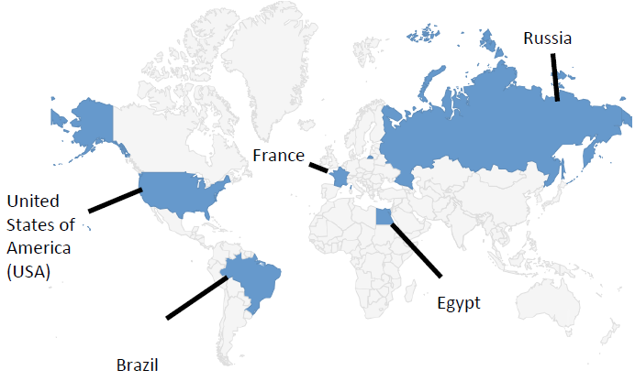
Country | Capital City | Continent | Human Geography |  | Physical Geography
_{France} | Paris | Europe | - Famous landmarks: Eiffel Tower, Arc de Triomphe, Disneyland Paris  - Trade: farming, fashion, wine  - High levels of tourism  - Main language: French |  | - Mountain ranges including the Alps  - Rivers, including the Seine  - Warm summers and cool winters (temperate)  - Has coasts on the English Channel
_{Russia} | Moscow | Europe | - Famous landmarks: St Basil’s Cathedral  - Trade: energy (oil, gas and coal)  - Largest population in Europe  - Main language: Russian |  | - Largest country in Europe by land  - Due to its size, there are many climate zones  - Has a coast on the Arctic Ocean – this part of Russia consists of a tundra biome
_{United States of America (USA)} | Washington DC | North America | - Famous landmarks: the White House in Washington DC and the Statue of Liberty in New York  - Trade: Farming, technology, tourism  - High levels of tourism  - Divided into states  - Main language: English |  | - Mountain ranges including the Rocky Mountains  - Niagara Falls: waterfall  - Due to its size there are many climate zones including deserts and Arctic tundra  - Has coasts on the Atlantic and Pacific oceans  - Lies on the edge of a tectonic plate
_{Brazil} | Brasilia | South America | - Famous landmarks: Christ the Redeemer statue  - Famous for the carnival held in Rio de Janeiro  - Trade: sugar, coffee  - Main language: Portuguese |  | - Amazon rainforest biome and river  - Tropical climate  - Lies on the line of the equator  - Coasts on the Atlantic ocean
_{Egypt} | Cairo | Africa | - Famous landmarks: the Great Pyramid of Giza  - Suez canal joins the Mediterranean and Red seas  - Popular for tourists due to hot weather and pyramids  - Main language: Arabic |  | - Hot, dry climate – consists of desert biomes  - River Nile  - Coasts on the Mediterranean and Red seas  - Lies on the line of the Tropic of Cancer

