*Office for National Statistics - **Population**

|  |  |
| --- | --- |
| Largest **cities** of the UK (by **population**)**\*** | |
| City Region | Approximate  **population** |
| Greater London | 8,674,000 |
| West Midlands | 2,834,000 |
| Greater | 2,756,000 |
| West Yorkshire | 2,282,000 |
| North East | 1,957,000 |
| Glasgow | 1,804,000 |
| Liverpool | 1,525,000 |
| Cardiff | 1,505,000 |
| Sheffield | 1,375,000 |
| Edinburgh | 1,350,000 |

Dynamics of UK **City** Regions

Liverpool

Bristol

Plymouth

Newcastle

Manchester Birmingham

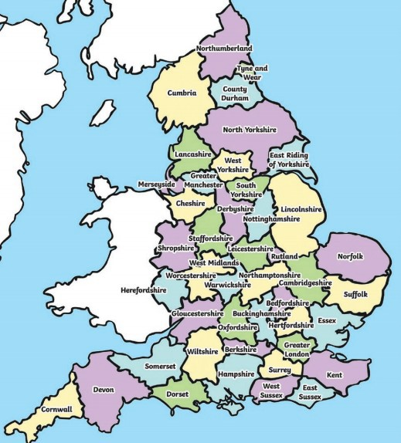

Cambridge

London

|  |  |  |
| --- | --- | --- |
| **What should I already know?** | |  |
| * The **town** I live in is called Haywards Heath, which is in West Sussex. There are **villages** and **towns** in West Sussex, some of which are **coastal**. * West Sussex is in England, which is a **country**. England, which is in the United Kingdom, is in the **continent** of Europe. * The capital **cities** of the four **countries** that make up the United Kingdom and their characteristics. * The surrounding seas of the United Kingdom. * The terms **urban** and **rural** and use them to describe areas of the UK. * How to locate places using four figure grid references. * How to identify features such as hills, mountains, coasts and rivers on a map. | |
| **Geographical Skills and Fieldwork** | |
| * Use aerial photographs to compare land use in Sussex and land use in London or another major **city.** Create a key using symbols to show what different features are. * Study Ordnance Survey **topographical** maps to plot land use patterns and features of **counties** of the UK. * Research how the **population** of Sussex has changed over time. Present this in a graph. Compare this to a similar graph showing the **population** of London. * Compare **urban** and **rural** areas using six-figure grid references. * Compare different sources for **population** numbers. Which is the most reliable? Why is it hard to measure **population?** * Use the National Grid to identify where different **counties** are using six-figure grid references. | |
|  | | |
| **Characteristics of the UK** | | |
| **Landmarks** | **Physical Features** | |
| Canterbury Stonehenge Cathedral    Angel of the North Clifton  Suspension Bridge    Roman Baths Edinburgh Castle | River Severn Ben Nevis    Lake District White Cliffs of Dover    Land’s End The Needles | |

|  |  |
| --- | --- |
| **Vocabulary** | |
| cartographer | somebody who draws and produces maps |
| city | a large **town**. London is a **city**. |
| coastal | an area of land close to the sea |
| compass points | any of the [main](https://www.collinsdictionary.com/dictionary/english/main) points of a compass: north, south, east, west, north-east, north-west, south-east, south-west |
| country | an area of land that is controlled by its own government. |
| county | a region of Britain or Ireland which has its own local government |
| human features | features of land that have been impacted by human activity |
| landmark | a building or feature which is easily recognised |
| landscape | everything you can see when you look across an area of land, including hills, rivers, buildings, trees and plants. |
| physical features | natural features of land |
| population | all the people who live in a country or area |
| rural | places that are [far](https://www.collinsdictionary.com/dictionary/english/far) [away](https://www.collinsdictionary.com/dictionary/english/away) from large towns or cities |
| topographical | the **physical features** of an area of land, for example its hills, valleys, and rivers |
| urban | belonging to, or relating to, a town or city |