Wow facts
Geography subject knowledge organiser— Explorers
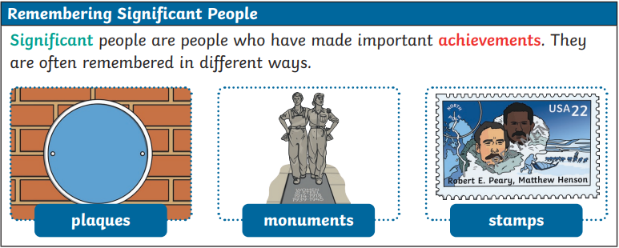
- Henson became a cabin boy when he was only 12 years. He was educated by Captain Childs who taught him to read and write. He treated Henson like a son.
- During the expedition, the main job of Henson was as a navigator. He also traded with the Inuit people and as a craftsman. Henson was capable of learning the language of Inuit people.
- Henson took part in the expedition of Peary after he was invited as a member of the Explorers Clube in 1937 because of his magnificent achievement. You have to know that Henson was the first African American person accepted as a member.
- A book published in 1991 was created to honour Henson. You can find the material about him, Peary’s Inuit, son and wife.
- Henson was born on 8 August 1866 in a farm in Nanjemoy, Maryland. His mother died went Henson was only two years old.
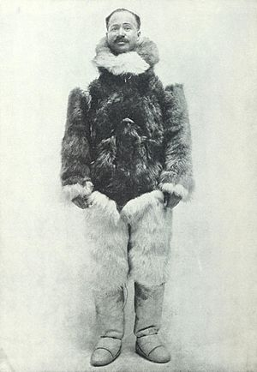  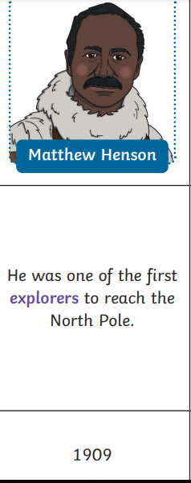  Key PeopleMatthew Henson | 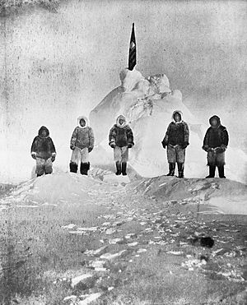  Diagrams/Pictures
Key Vocabulary
Word | Meaning
Chronological | Placing a record of events following the order in which they happen
Century | A period of 100 years
Decade | A period of ten years
Achievement | An Achievement is something challenging that someone does well
Equipment | Objects that are needed for an activity, such as exploring
Expedition | A journey taken for a reason such as exploring somewhere or something
Explorer | Someone who goes on a journey to find out about somewhere or something new.
Polar | Polar describes anything about (or near) the North Pole or South Pole
Significant | Important and worth knowing about
North Pole | Northern end of the Earth’s axis, lying on the Arctic Ocean, about 450 miles north of Greenland
Crevasse | A deep hole or crack in a glacier or the Earth
Inuit | A member of a native people of Northern Canada and parts of Greenland and Alaska

